East Area Planning Committee | - 7th March 2012

Application Number: | 12/00077/FUL
Decision Due by: | 19th March 2012
Proposal: | Erection of single and two storey side, front and rear extensions and alteration to roof. Sub-division to form two bedroom dwelling provision of parking to front
Site Address: | 77 Sandfield Road (Appendix 1)
Ward: | Headington Ward

Agent: | Mr Saeed Khan | Applicant: | Dr Z Jiang

Call in: The application was called in by Councillors Wilkinson, Rundle, Mills, Jones and Campbell on the grounds of concerns expressed by Highway Authority about the vicinity of the access to the bend in the road and the need for parking spaces to conform with new parking standards.

Recommendation: It is recommended that planning permission be approved for the following reasons:

1 The principle of the development was established by the extant planning permissions (ref 10/02781/FUL and 11/00051/FUL). The application seeks to bring these two permissions together under one consent with some small alterations that are not considered to unacceptably impact on neighbouring properties or the character and appearance of the building or street. Adequate car parking is provided in accordance with Appendix 3 of the Local Plan. The application accords with policies CP1, CP6, CP8, CP10, TR3, TR4, HS19, HS20 and HS21 of the Oxford Local Plan 2001 - 2016 and policies CS2, CS18 and CS23 of the Oxford Core Strategy 2026.

2 Officers have considered carefully all objections to these proposals. Officers have come to the view, for the detailed reasons set out in the officers report, that the objections do not amount, individually or cumulatively, to a reason for refusal and that all the issues that have been raised have been adequately addressed and the relevant bodies consulted.

3 The Council considers that the proposal accords with the policies of the development plan as summarised below. It has taken into consideration all other material matters, including matters raised in response to consultation and publicity. Any material harm that the development would otherwise give rise to can be offset by the conditions imposed.

Conditions:
1 Development begun within time limit
2 Develop in accordance with approved plans
3 Materials - matching
4 Boundary treatment to accord with plans
5 Landscaping to accord with plans
6 Car parking to accord with plans
7 Vision Splays
8 Removal from controlled parking zone
9 Bin and cycle storage
10 Northeast bathroom window obscure glass
11 Design - no additions to dwelling

Principal Planning Policies:

Oxford Local Plan 2001-2016
CP1 - Development Proposals
CP6 - Efficient Use of Land & Density
CP8 - Design Development to Relate to its Context
CP10 - Siting Development to Meet Functional Needs
CP11 - Landscape Design
TR3 - Car Parking Standards
TR4 - Pedestrian & Cycle Facilities
HS19 - Privacy & Amenity
HS20 - Local Residential Environment
HS21 - Private Open Space

Oxford Core Strategy 2026
CS2_ - Previously developed and greenfield land
CS9_ - Energy and natural resources
CS18_ - Urban design, town character, historic environment
CS23_ - Mix of housing

Sites and Housing DPD – Proposed Submission
HP9_ - Design, Character and Context
HP11_ - Low Carbon Homes
HP12_ - Indoor Space
HP13_ - Outdoor Space
HP14_ - Privacy and Daylight
HP15_ - Residential cycle parking
HP16_ - Residential car parking

Other Material Considerations:
PPS 1 – Delivering Sustainable Development
PPS 3 – Housing
PPG 13 – Transport
Regional Spatial Strategy for the South East
Balance of Dwellings Supplementary Planning Document
Parking Standards Supplementary Planning Document
Manual for Streets

Relevant Site History:
10/02781/FUL - Alteration to front and rear elevation to include porch and rear patio door. Conversion of existing two storey side extension to self contained one bedroom house- provision of 3 car parking spaces to frontage plus cycle and storage for bins and provision of amenity space to rear – Approved

11/00051/FUL - Erection of part single storey, part two storey, extensions to the side and rear and single storey front extension. (Amended plans) – Approved

11/02153/VAR - Variation of conditions 5 and 7 of planning permission 10/02781/FUL for extension and creation of one bedroom house, to allow details of landscaping to be submitted following commencement of development, and car parking spaces to be laid out after occupation – Withdrawn

11/02155/VAR - Variation of conditions 5 and 10 of planning permission 11/00051/FUL for extension to front – Withdrawn

11/02243/FUL - Demolition of existing rear single storey extension and front porch. Erection of single and two storey side and rear extension, front porch and alterations to roof. Subdivision to form 1 bed house. Provision of car parking – Withdrawn

11/02816/FUL - Demolition of existing rear single storey extension and front porch. Erection of single and two storey side, front and rear extension, and alterations to roof. Sub-division to form 2 bed house and provision of car parking - Withdrawn

Third Party Representations Received: At the time this report was drafted no letters of comment and been received. However, the consultation period has not yet expired and as such officers will report any comments received verbally at the Committee.

Statutory and Internal Consultees:
Highways And Traffic – No objection – some initial concern raised about the proximity of new access to junction, however it has been acknowledged that part of this is existing and as such no objection to this has been formally raised. Conditions have been suggested to secure visibility splays, porous surface treatment and cycle storage.

Thames Water Utilities Limited – No objection

Officers Assessment:

Site Description and Proposal
- The application site comprises No 77 Sandfield Road, a two storey detached property within a predominately residential area. The building is presently undergoing alterations to the front, side and rear. Prior to these works the property had already been extended to the side and rear.

- The application proposes the erection of a single and two storey side and rear extension and single storey front porch in connection with the subdivision of the property to provide two houses (1x2 bed and 1x4 bed). It is proposed to widen the existing access on the site frontage to accommodate two additional cars (3 spaces in total).

- Officers consider the main issues of the case to be the planning history and the principles that have been established therein, the impact on neighbouring properties, the proposed residential environment, the visual impact, and car parking.

Planning History
- Planning permission was granted in 2010 to convert the earlier side extension into a one bed house. As part of that proposal a separate rear garden and car parking space was proposed (this property was known as 77A Sandfield Road). In 2011 planning permission was granted to erect a single and two storey extension to the side and rear of the original house (known as 77 Sandfield Road). Work has commenced on site, however these works differed from the approved plans and included additions to 77A Sandfield Road which were not approved under the 2010 permission. As a result a fresh planning permission is required to regularise what has/is being constructed and to bring the 2010 and 2011 planning permissions together as they could not technically be implemented together under the separate permissions.

- The following differences were identified between the approved applications and what was being constructed on site:

  - The porch is 300mm closer to the boundary with No 79 Sandfield Road;
  - The rear ground floor extension is 200mm closer to the boundary with No 79 Sandfield Road and its roof form has changed to incorporate a small area of flat roof to the rear of No 77A Sandfield Road;
  - The roof of the single storey side extension adjacent to No 75 Sandfield Road, previously fully glazed, has been replaced with tiles with two roof lights inserted;
  - The rear single storey extension now has two roof lights;
  - The rear French doors of No 77A Sandfield Road are lower than originally approved;
  - The 1st floor rear extension adjacent to No 79 Sandfield Road is 200mm closer to the boundary;
  - The internal layout of No 77A Sandfield Road has changed, with an additional room in its roof space (lit by roof lights);
  - Two roof lights have been omitted above bedroom 4 (within the roof) in No 77 Sandfield Road. A storage area has been included which is lit by two new roof lights on the southeast roof slope;
  - The roof lights on the ground floor extension roof are actually casement windows set into the roof;
  - The rear facing 2nd floor gable window was constructed larger than approved.

- There are also some internal alterations to No 77 Sandfield Road, however these do not require planning permission. The above alterations are shown on figure 1 below where the proposed plan has been overlaid by the outline of the approved plan.

Figure 1

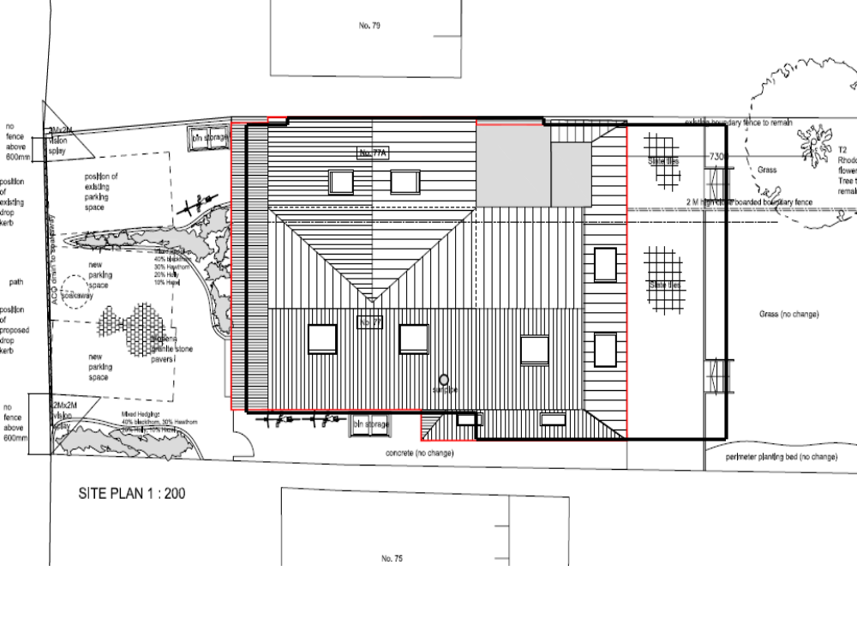

- As can be seen from figure 1, the proposed extensions are only marginally larger than those which have been approved. In such cases CLG Circular 03/09 - Costs Awards in Appeals and Other Planning Proceedings points out that a planning authority may be considered to have acted unreasonably if it does not determine like cases in a like manner. The Circular further explains that a Planning Authority may be vulnerable to costs in two other circumstances noted in the circular, a) where it fails to grant permission for a scheme that is subject to an extant or recently expired permission, and b) where there has been no material change in circumstances. In this regard officers would advise that as the changes in the size of the extensions are only very minor (300mm at most) it would not be reasonable to resist the principle of the extensions, or for that matter the principle of the new house. Officers would therefore recommend that the previous permission be afforded considerable weight in assessing the current application.

Impact on Neighbouring Properties
- Local Plan policy CP10 states that development should be sited to ensure that the ‘use or amenity of other properties is adequately safeguarded’. Whilst policy HS19 goes further and explains that planning permission will only be granted for developments that adequately provide for the protection of the privacy or amenity of the occupants of the proposed and existing neighbouring residential properties.

- The porch and rear single storey extension of No 77A Sandfield Road would be 300mm and 200mm closer to No 79 Sandfield Road. There are ground floor habitable room windows in both the front and rear elevation of No 79. The front window is a bay window which is of sufficient size and distance away from the porch so as to not suffer any unacceptable loss of light or outlook. Whilst the rear window is again of a sufficient distance away so as to not be unreasonably affected by the marginal encroachment of the proposal. Officers conclude that the difference in impact between the approved extensions and those proposed is very minor and would not give rise to significant additional harm.

- The proposals would be no closer to No 75 Sandfield Road than the approved scheme and as such there would be no material change to the impact on daylight to No 75.

- The new roof lights would not look directly into neighbouring gardens and officers conclude that they are therefore acceptable. The omission of the glazed roof of the single storey extension adjacent to No 75 Sandfield Road and its replacement with a tile roof with roof lights would not materially affect the privacy of No 75, indeed it would improve the situation.

Proposed Residential Environment
- Local Plan policy HS21 states that residential development should have access to private amenity space. Units with 2 or more bedrooms are required to have exclusive access to an outdoor space and where the unit is a house the garden should generally be a minimum of 10m in length. The existing house would retain a substantial rear garden in excess of 10m, while the new two bed dwelling would have a rear garden approximately 10.8m in length. The proposal would therefore comply with policy HS21.

- The Local Plan does not give standards for the layout or size of houses. They should however be well lit and provide a good environment with space enough for furnishings. The ground floor of 77A Sandfield Road would be lit by windows to the front and rear and as such the rooms would receive an acceptable level of light and ventilation. The layout is such that it would allow sufficient space for storage and furnishings suitable for a dwelling of this size and type.

- The proposal includes bin and cycle storage which is of adequate size and located within easy access of the street. This provision accords with Local Plan policies CP10 and HS19.

Visual Impact
- The proposed external alterations are very minor and would not significantly change the appearance or scale of the development. Officers therefore consider the visual impact on the site and character of the area to be acceptable.

- The roof lights that were originally intended for the single storey side and rear extension have been replaced by casement windows. The windows have been set into the roof so that they do not project above the plane of the roof to any greater extent than a roof light. Because of this, and the location of the windows at the side and rear of the property, they can not be seen from the public realm and officers therefore conclude that in this particular instance they are acceptable.

Car Parking
- Three off street car parking spaces are proposed, one for the new house and 2 for the existing house. This level of parking provision would not fully comply with the maximum standards set out in the Local Plan, however the Local Plan supports reduced parking provision in sustainable locations such as this and there are on street parking controls to prevent any additional parking on the highway. The site is within an accessible location and a Controlled Parking Zone. In the light of this officers consider the level of parking to be acceptable. The recommendation includes condition 8 to remove the houses from entitlement to parking permits.

- The Highway Authority had initially raised concerns about the proximity of the access to the bend in the road, however this has since been withdrawn on the basis that the original house had an access in the same position and that the parking and new access have been approved under the previous applications. The Highway Authority has recommended conditions relating to visibility splays and that the parking area is SUDs compliant.

Sustainability
- The application site lies within a sustainable location, on the edge of the Headington District Centre. The site therefore has excellent access to shops, services and public transport nodes. The proposal will make efficient use of the site.

- Policy CS9 of the Core Strategy states that all applications for development are expected to minimise carbon emissions by incorporating sustainable design and construction methods into the development. The application is silent on this issue, however parts of the Building Regulations, in particular Part G (Sanitation, Hot Water Safety and Water Efficiency) and Part L (Conservation of fuel and power), aim to help reduce carbon emissions and protect the environment.

- Although ordinarily officers would suggest a condition requiring details of how sustainable design and construction methods would be incorporated into the building, this application is a minor reworking of two previous planning permissions which did not include such a condition. As the approved works are now well advanced officers would in this particular instance recommend that the condition not be imposed as any such measures could not now be reasonably accommodated.

Conclusion: The principle of development was established in granted planning permission under references 10/02781/FUL and 11/00051/FUL. The difference between those schemes and the one before Committee are not considered to give rise to an unacceptable adverse impact on neighbouring properties or the character and appearance of the area. Officers would therefore recommend that planni9ng permission be granted subject to conditions.

Human Rights Act 1998

Officers have considered the Human Rights Act 1998 in reaching a recommendation to grant planning permission, subject to conditions. Officers have considered the potential interference with the rights of the owners/occupiers of surrounding properties under Article 8 and/or Article 1 of the First Protocol of the Act and consider that it is proportionate.

Officers have also considered the interference with the human rights of the applicant under Article 8 and/or Article 1 of the First Protocol caused by imposing conditions. Officers consider that the conditions are necessary to protect the rights and freedoms of others and to control the use of property in accordance with the general interest. The interference is therefore justifiable and proportionate.

Section 17 of the Crime and Disorder Act 1998

Officers have considered, with due regard, the likely effect of the proposal on the need to reduce crime and disorder as part of the determination of this application, in accordance with section 17 of the Crime and Disorder Act 1998. In reaching a recommendation to grant planning permission, officers consider that the proposal will not undermine crime prevention or the promotion of community safety.

Background Papers: 12/00077/FUL, 10/02781/FUL, 11/00051/FUL

Contact Officer: Steven Roberts
Extension: 2221
Date: 22nd February 2012

Appendix 1



